James Chad Ballay

1. Using a device connected to a network, determine the following\*:
   1. Manufacturer of the host’s equipment.

Intel Corporation



* 1. Device’s MAC address

98:3b:8f:8c:5d:9d

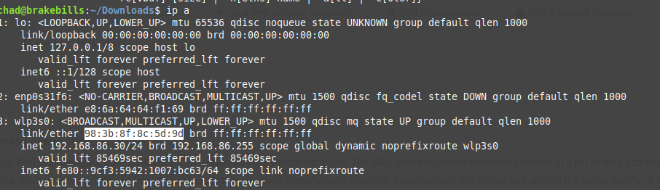

* 1. The vendor who assigned the MAC address. We determine this from the “vendor unique address” in the MAC address.

98:3B:8F

Intel (<https://dnschecker.org/mac-lookup.php>)

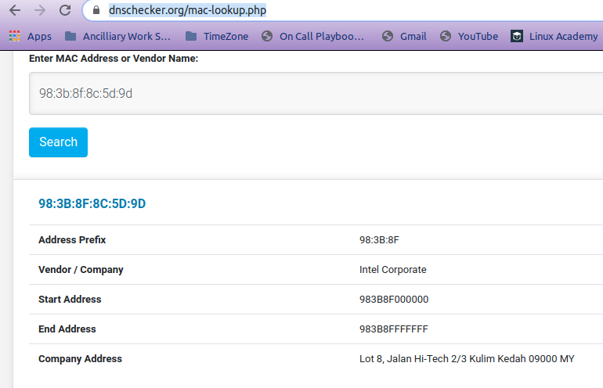

* 1. If possible, include a screenshot of the devices MAC address.

1. List and briefly explain in your own words the seven layers in the OSI Protocol Model.

<https://en.wikipedia.org/wiki/OSI_model>

Layer 1 – Physical Layer. This is the land of physics. Copper wire, radio frequencies, and glass. The tangible medium of the connection.

Layer 2 – Data Link Layer. Converts the electrical impulses, waves of radio frequencies or blinking of photons into bits.

Layer 3 – Network Layer. Routing of the bits. You want to talk to that computer over there? Well this is the part of the model that figures out the path between here and there.

Layer 4 – Transport Layer. Handles error correction and speed. I send a flock of packets this is where the knowledge of the whole message and the correct order of those packets gets hashed out.

Layer 5 – Session Layer. The layer responsible for establishing, maintaining and ending connections between different applications.

Layer 6 – Presentation Layer – Formats of data. ASCII. JPG. TXT. These are the units of communication done at this layer.

Layer 7 – Application Layer – User interaction exists and communicated at this layer. For instance, you click on a link, it really is a https call being made due to that action.